E-COM EXPRESS CASE STUDY
PROJECT REPORT
INTRODUCTION TO THE BUSINESS
E-Com Express, founded in 2010 and based in the United States, is a fast-growing e-commerce retailer specializing in consumer electronics, home appliances, and lifestyle products. Initially starting as a small online store, the company quickly gained traction with its emphasis on providing high-quality products at competitive prices. The company primarily offers a wide range of consumer electronics, home appliances, and lifestyle products such as fitness gear, kitchen gadgets, and gaming equipment. E-Com Express differentiates itself through exclusive deals, flash sales, and targeted promotional offers, all of which are integral to its marketing strategy. E-Com Express operates in a competitive environment with a focus on product variety, fast delivery, and customer service, their current baseline conversion rate is around 2.5%.
PROBLEM STATEMENT FOR THE PROJECT
Industry data shows 66% of customers consider free shipping crucial, and
52% abandon carts due to unexpected shipping costs.
1. Low Conversion Rate Despite High Traffic. Despite significant investment in digital marketing and a robust online presence, E-Com Express has been facing a concerning challenge: a low conversion rate.
2. Pricing Sensitivity. Customers abandon carts when shipping costs appear at checkout
3. Customer Expectations. Competitors' free shipping offers have set new market standards
TOP 5 REASONS FOR INITIATING THIS PROJECT
- Test the effectiveness of discounts vs. free shipping on conversion rates
- Measure customer behaviours’ including cart abandonment and order value
- Optimize revenue and conversion cost-effectively
- Refine marketing strategies to maximize ROI
- Improve customer loyalty through better understanding of preferences
RATIONALE FOR THIS PROJECT
1. Increased Conversion Rates. Drive more purchases and reduce cart abandonment

2. Enhanced Customer Satisfaction. Improve brand loyalty with appealing promotions

3. Optimized Marketing Spend. Reduce wasteful ad spend with targeted promotions

4. Improved Profit Margins. Increase sales without eroding profits

CASE STUDY OBJECTIVES
DATA DESCRIPTION
✓ order_date
Date the order was placed
✓ customer_id
Unique identifier of customer
✓ order_status
Whether order has been completed or not
✓ offer_id
The choice of promotional offer chosen by customer
✓ loyalty_status
Customer value
✓ price
Price of product
✓ offer_value
DATA ANALYSIS PROCESS
PREPARE PHASE: The data to be used for this project is gotten from the company’s database system. For the purposes of this case study, the datasets are appropriate and will enable us to find solution to the business problems. A snip of the datasets is shown below:
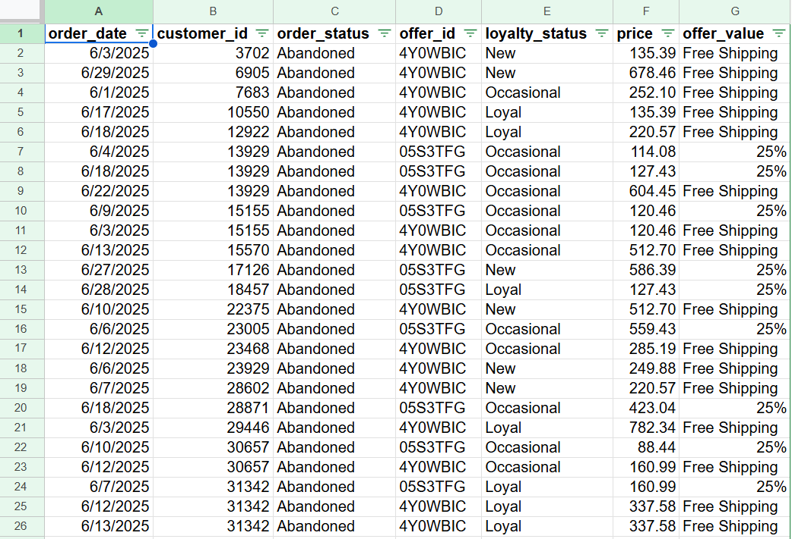

PROCESS PHASE
The following steps were taken to process the data
- Download the data from the company’s database
- Unzip the files
- Create a folder on desktop to house the files. Use appropriate file-naming conventions.
- Create subfolders for the .csv file and the .xlsx or Sheets file so that original copy of data is available. Move the downloaded files to the appropriate subfolder.
In Google Sheets
- As soon as the data was cleaned, they were moved to Google sheets for analysis
- A/B Testing was used for this analysis to check which promotional offer is better
- Hypothesis was carried out with the aid of the 5’C: Create the hypothesis, Check conditions, Calculate, Compare using the standard conditions (random sample. Np>10) and Conclude to either reject the null hypothesis or fail to reject.
- After the analysis, I generated the z-statistics, the P1 and P2 and the sample size (n). Below is a screen shot of the analysis on google sheets
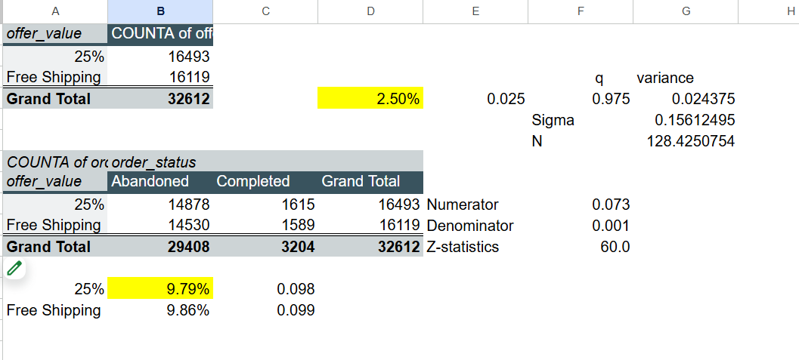
SHARE PHASE
After analysing the data, Visualization was made using looker studio to support and present key findings. The visualization below shows visuals highlighting the two promotional offers: The 25% discount and Free shipping.
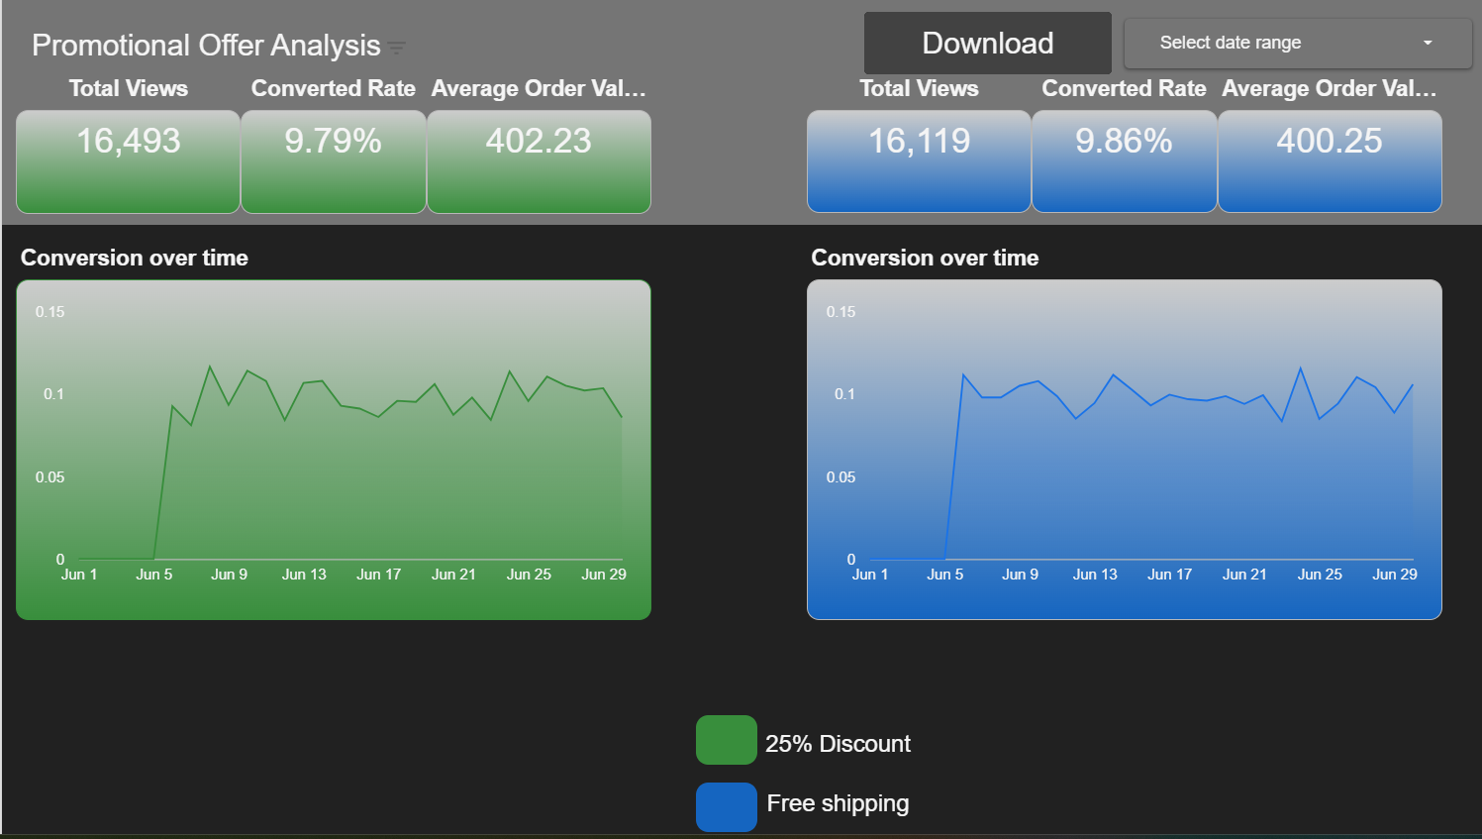
INSIGHTS AND RECOMMENDATIONS
Below are the insights generated from the analysis
📈
- Both promotional offers were successful in driving conversions and sales: The 25% discount and free shipping promotions both achieved a high conversion rate, with values of 9.79% and 9.86%, respectively. This indicates that customers are responsive to these types of offers.
- The free shipping promotion had a slightly better performance: It had a marginally higher conversion rate (9.86% vs. 9.79%) and a slightly lower average order value ($400.25 vs. $402.23) despite the higher traffic (16,493 views vs. 16,119 views). The lower AOV is expected as shipping costs are likely lower than a 25% discount. This suggests that free shipping is a strong motivator for a large number of customers.
- The conversion rate for both offers was volatile: Both charts show significant day-to-day fluctuations in conversion rates. This suggests external factors like day of the week, marketing campaigns, or a new product launch could have influenced daily performance.

RECOMMENDATIONS 💡
- Test a combined offer: Since both promotions performed well individually, you should run a controlled experiment to test a combination of a smaller discount (e.g., 10-15%) plus free shipping to see if it can drive an even higher conversion rate and average order value. This could be the most effective strategy.
- Analyse the impact of different days and external events: You should dig deeper into the conversion data to identify the cause of the volatility. By analysing performance by day of the week, and correlating it with marketing efforts or product releases, you can optimize when to run promotions for maximum impact.
- Conduct A/B testing on different offers: To continue to optimize your promotions, you should implement a structured A/B testing program. This would allow you to test new ideas and determine which offers provide the best return on investment. For example, test a free gift with purchase, a buy-one-get-one-free deal, or a tiered discount.

